DLD lab report 3
student number: 16329561

This lab we needed to implement a 4 input Boolean function with the following minterms.

F(w,x,y,z) = Σm(1,4,5,11,12,14,15) + Σmd(2,3,7,9)

With a karnaugh map of the max terms, I was able to get 8 literals and the following circuit:

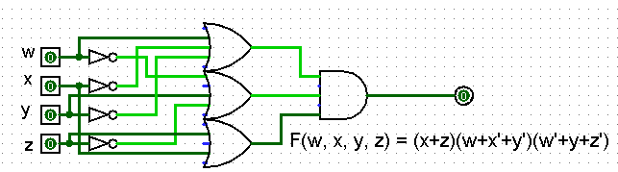
The truth table of this function is as follow:
W | X | Y | Z | F(w,x,y,z)
0 | 0 | 0 | 0 | 0
0 | 0 | 0 | 1 | 1
0 | 0 | 1 | 0 | -
0 | 0 | 1 | 1 | -
0 | 1 | 0 | 0 | 1
0 | 1 | 0 | 1 | 1
0 | 1 | 1 | 0 | 0
0 | 1 | 1 | 1 | -
1 | 0 | 0 | 0 | 0
1 | 0 | 0 | 1 | -
1 | 0 | 1 | 0 | 0
1 | 0 | 1 | 1 | 1
1 | 1 | 0 | 0 | 1
1 | 1 | 0 | 1 | 0
1 | 1 | 1 | 0 | 1
1 | 1 | 1 | 1 | 1

With the Karnaugh map where we group the max terms, we need to group all the maxterms, we can the don’t cares to help the grouping and make bigger groups which result in less literals. But we don’t have to group all the don’t cares. Once we have our maxterms grouped, we do a product-of-sum. We can than simplify the expression using the distributivity law if there is the same variable appearing multiple time in the expression.

